

**Submitted by : Spogmai Jan**

**Roll No : 2430 - 0081**

**Submitted to : Dr. Jawad Hussain**

**Subject : Programming Fundamental**

**ASSIGNMENT :02**

**TASK 01 :** Define three products with fixed prices (e.g., Product A, Product B, and Product C).

Ask the user to input the quantity they want to buy for each product.

Calculate the total cost by multiplying the price by the quantity for each product.

SOLUTION**:**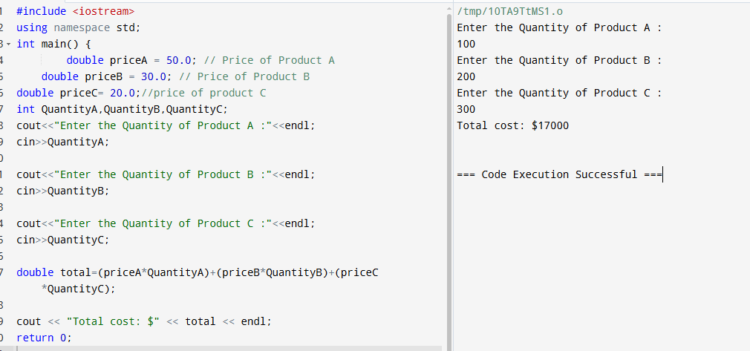

**TASK 02:** If the total price is greater than $200, apply a 10% discount. Otherwise, no discount is applied.

Use a ternary operator to calculate the discounted total.

SOLUTION**:**

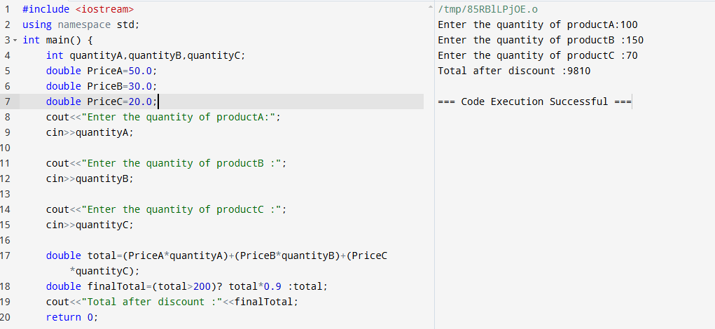

**TASK 03:** If the total after discount is less than $150, add a $15 shipping fee. If the total is $150 or more, shipping is free.

Use comparison and logical operators to determine whether to apply shipping.

SOLUTION**:**

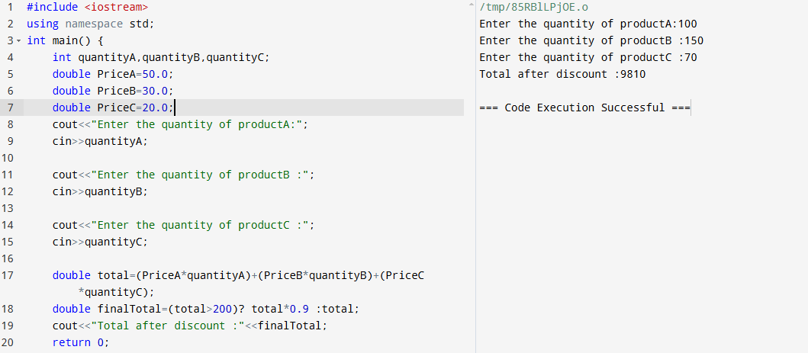

**TASK 04:** If the final total after shipping is more than $300, the customer gets 50 loyalty points. Otherwise, they get 20 points.

Use logical operators (>) and comparison to decide the number of points.

SOLUTION**:**

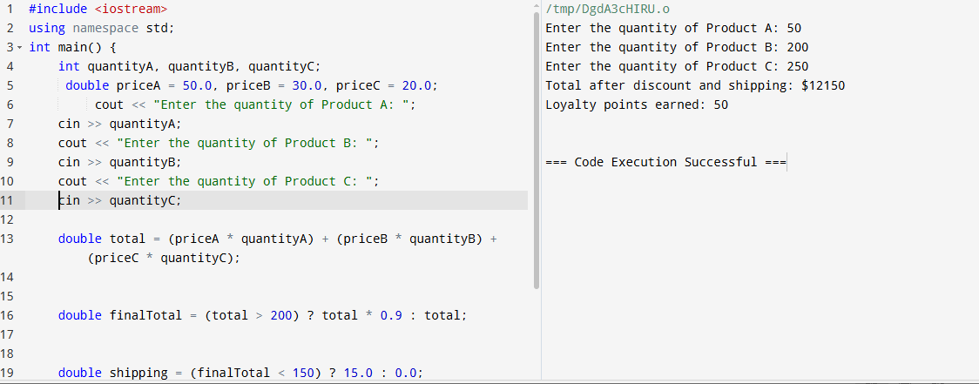

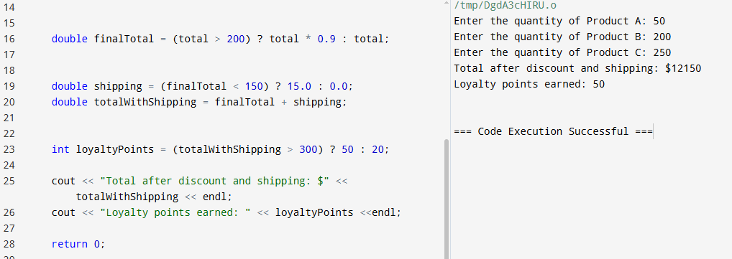

**TASK 05:** Bring together the product selection, discount system, shipping fee, and loyalty points into a single program.

Ensure the program is easy to follow and outputs the final total, shipping cost, and loyalty points.

SOLUTION**:**

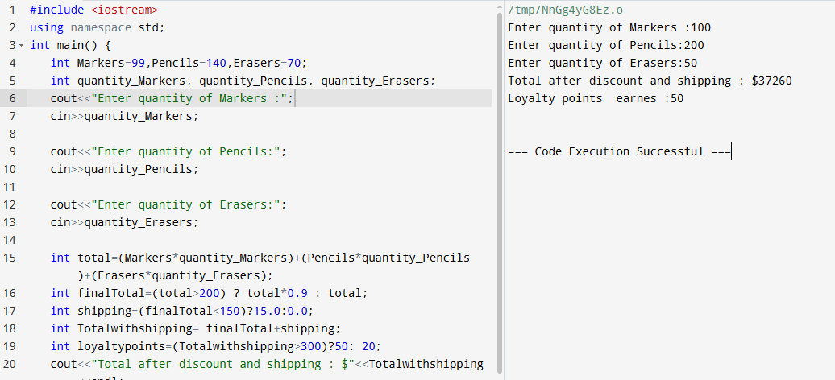

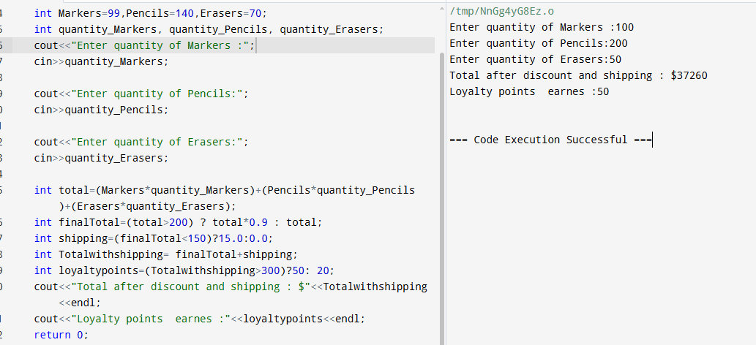

**--------- THE END --------**